**Introduction to GIS**

**Assignment Week 06**

Sometimes, the attributes of the layers we have collected do not have all the data we want. For example in an Educational file, we have seen attributes for bachelors, masters and doctorates. What if our research needed a total of graduate degrees? There is no attribute for that. In this case, we might want to compute the sum of two attributes (masters and doctorates). As another example, in the Education Layer we used, it did not have totals for a males and females in any category. We might want to compute sums depending on the applications.

This week:

1. Learn a new Data Source Tool: *Social Explorer*
2. Create new attributes from two or more by computing new values

**For every map from now on.**

With an open blank map we will want to do some setup before getting started. This should be for every map. These actions have been described and demonstrated in previous assignments:

*Set the pathname to “relative” –make it easier to share map folders*

File->Map Document Properties->Check “Store relative pathnames to data sources

*Page Layout – set to landscape or portrait*

Layout icon->Letter (ANSI A) Landscape.mxd

*Map Background Color*- Set background color for more professional looking map

Right Click Layers->Properties-Frame tab->Set the background color

*Coordinate System –*

Right click Layers –Choose Layer Properties->Select Coordinates Tab-> Geographic Coordinate Systems _> Expand North America -> Expand USA and territories -> Select NAD83

**Other Consideration for all maps:**

* *Include Title, Legend, Scale Bar, North Arrow*
* *Export the “display/layout” unless instructed differently*
* *use symbology to make the data more presentable (line widths, color, symbol size)*
* *Label features if not too cluttered*
* *Make sure, for selections, you have created a new layer and removed selections*

**Downloading the basemap**

1. Navigate to the US Census Tigerline Data website: <https://www.census.gov/geographies/mapping-files/time-series/geo/tiger-line-file.html>
2. Go to the *Web Interface* – near the bottom in green.
3. Select year: 2010
4. Select a layer type: *Counties and Equivalent*
5. In the second dropdown menu select New York – Select Download
6. Copy the downloaded file to your folder for this week and unzip
7. Start Arcmap and add the basemap
8. Save the map as *yourlastnameCrime.mxd*

**Downloading Demographic Data: Social Explorer**

*Social Explorer* is a licensed data tool for both mapping and data download. It aggregates data from several sources including the US Census, FBI, and other sources. For this exercise, we want to look at crime data from the “Uniform Crime Reporting” system (UCR). Its easiest access is through *Social Explore*r.

**Create an account**

1. **IMPORTANT: You must be on the campus network to create a Social Explorer Account. After that, you can log in from anywhere**.
2. Navigate to *socialexplorer.com*
3. Select SIGN UP (at the bottom)
4. Enter your credentials. Best is to use your Pace credentials
5. Log In.
6. **NOTE: You must be on the campus network when you do this, otherwise you will not have a full access account.**

**Getting the Crime Data**

1. Choose *Tables* at from the list on the right
2. Select *UCR CRIME DATA 2010 ->Begin Report*
3. In the Geography pull-down menu select *County*
4. Select *New York*
5. Select *All counties in New York*
6. Select *Add*
7. Proceed to *Tables*

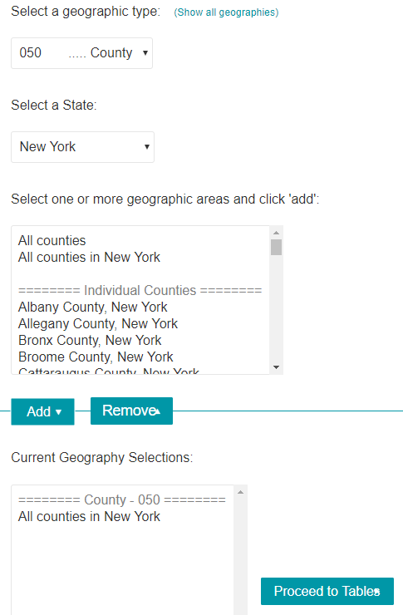

1. Select *Social Explorer Tables: UCR Crime Data 2010*
2. Select *Table T1 (Total Population) and T12 (Arrests)*
3. Select *Add*
4. Select *Show Results*
5. Select the 3rd tab at the top -> *Data Download*
6. For Output options, select the last one, *Output DBF*
7. For *Download data by geography type:*, select *County data (CSV)*
8. For *Download programs to import and label Data*:, Select *Data dictionary*
9. Move the .csv and .txt files to your folder for Week 06.
10. Look at the Data Dictionary File, *R12317392.txt*.
11. The Data Dictionary is summarized at the end of this document. It contains the attributes we will be using.

**Cleaning up the crime table spreadsheet**

1. There are a few issues here:
   1. The last row (64) doesn’t make sense and should be removed. It appears to apply to outliers not assigned to a county. It will not survive the Join!
   2. The attributes for the crime statistics are 11 characters. Column names for ArcMap must be 10 or less. Simply remove the “SE_”prefix.
   3. Finally, in the spreadsheet, St. Lawrence County is missing the “.” (which is in the basemap). So modify “St -> St.
2. Save the .csv file as *CrimeClean.csv*
3. In ArcMap, add CrimeClean.csv.
4. Look at the Attribute table for *NYS Counties* and the *CrimeClean* table. Note that we can join around *NAMELSAD10* in *NYS Counties* and *Geo_Name* in *CrimeClean.*
5. Join the table to *NYS Counties*
6. Create a Shapefile for the joined layer:
7. Right mouse-click->Data->Export-Data
8. Navigate to your Week06 folder and name the layer *NYSCountyCrimeData.shp*
9. Add the new shapefile to the map (it’s an option) and remove *tl_2010_36_county10* (the original basemap) and the original table.
10. Save the map, NYSCountiesCrime.

**Calculating and creating new attributes**

In a search for a new home, we are interested in safe communities. Safe could mean low incidence of property crime (burglaries and auto theft). We going to create a new attribute which is the sum of these two.

1. Open the attribute table of the shapefile with the join that we just added (*NYSCountyCrimeData.shp)*.
2. Select the top right Icon and select “Add Field”. In the popup window, call it BurgAuto. There rest can default. Short Integer means not a fraction.

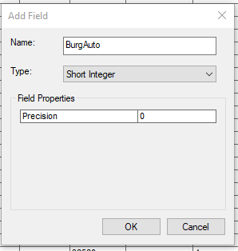

1. In the Attribute Table look at the right most column. It should be the new Field.
2. Right Click the Heading and in the pulldown menu select *Field Calculator*. Create an expression that is the sum of Total Arrests for Burglary (T010­_006) and Total Arrests for Auto Theft (T010_008)

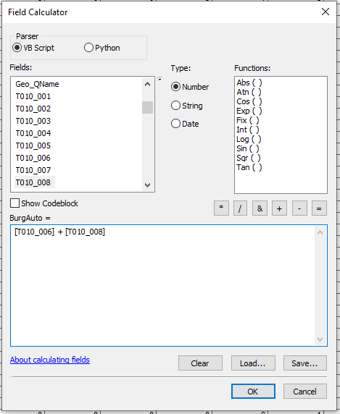

1. Check that the calculation was successful.

Make 2 copies of the New Layer

1. Make 2 copies of *NYSCountiesCrimeData* (Right Click->Copy; Right click Layers->paste; 2 times)
2. Rename the Original layer *NYSCountiesBurgAutoColor-Coded*
3. Rename the first copy *NYSCountiesBurgAutoSelection*
4. Rename the second copy *NYSFCFEColor-Coded*
5. Turn off the copies leaving the original layer, *NYSCountiesBurgAutoColor-Coded*
6. Save the map.

**Color-Coded Map and Selection by Attribute**

As a review, we can look at the new attribute in several ways – a color-coded map and as a map with a threshold criterion.

***Color-Coded Map (Review)***

1. Create a color coded map (Properties->Symbology->Quantities->Graduated Colors)
2. In Display view: Set to landscape; set background color; add North Arrow, Legend, Scale Bar and Title
3. Export the map as a jpeg: yourlastnameNYSBurgAutoColor-Coded.jpg
4. Save the map

***Selection by Attribute(Review)***

Suppose we are interested in counties with low combined Burglary and Auto Theft counts. Set up a map that shows counties where the count is less than 75.

1. Turn *NYSCountiesBurgAutoSelection* and turn off the original layer (*NYSCountiesBurgAutoColor-Coded)*
2. Choose *Selection -> By Attribute*
3. Set *BurgAuto < 75*
4. Create a layer from the selection (*NYSCountiesBurgAutoSelectionLess75)*
5. Clear the selection
6. In Layout View add the required map components for publication (Title, North Arrow, etc.)
7. NOTE. Delete the legend and re-insert to make sure you get the visible layers.
8. Remember to modify the Title
9. Export as a .jpg: yourlastnameNYSCountiesBurgAutoLess75.jpg
10. Save the map.

**On Your Own**

Repeat the exercise looking at different “white collar crimes”:

T010_011: --Forgery and Counterfeiting

T010_012: --Fraud

T010_013: --Embezzlement

1. Turn off the *NYSCountiesBurgAutoSelection and NYSCountiesBurgAutoSelection*Less75 Layer; turn on *NYSFCFEColor-Coded*.
2. Create a new field (NYSFCFE) -> Attribute Table->Add Field
3. Calculate the sum of the 3 crimes-> Right click the column heading->Field Calculator

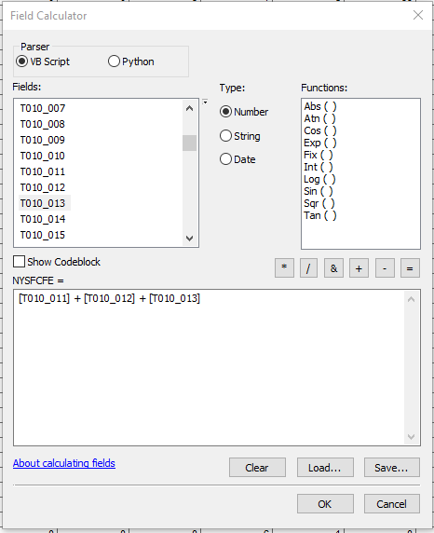

1. Create a copy of the layer with the new calculated field.
2. Rename the copy *NYSFCFESelection*
3. Save the map.
4. Using the NYFCFEColor-Coded layer, create a color-coded map using the new field, NYSFCFE.
   1. In Display View add the required elements.
   2. Export as a .jpg (yourlastnameNYSFCFEColorCoded.jpg)
5. Turn off turn off the current layer, turn on the last copy.
6. Using the NYSFCFESelection layer create map with select by attribute where NYSFCFE < 75
   1. Choose Selection -> By Attribute
   2. Create a layer from the selection; rename the layer; clear the selection
   3. In Display View add the required map components for publication (North Arrow,etc.)
   4. Remember to modify the Title
   5. NOTE. Delete the legend and re-insert to make sure you get the visible layers.
7. Export as a .jpg: *yourlastnameNYSCountiesNYSFCFELess75.jpg*
8. Save the map

**Psychic Extra Credit (no points just gratification!)**

Create a compound selection where we select counties where BurgAuto AND NYSFCFE are both less than 75.

**What is due this week (10/15/2019)**

Place 4 jpgs in a single word document:

1. yourlastnameNYSBurgAutoColor-Coded.jpg
2. yourlastnameNYSCountiesBurgAutoLess75.jpg
3. yourlastnameNYSFCFEColorCoded.jpg
4. yourlastnameNYSCountiesNYSFCFELess75.jpg

***Crime Data Dictionary***

Survey: UCR Crime Data 2010

Dataset: Social Explorer Tables: UCR Crime Data 2010

Tables:

1. Total Population (2010 est.)

Universe: Universe:

Name: T1

Variables:

T001_001: Total Population

16. Arrests

Universe: Total Arrests

Name: T12

Variables:

T010_001: Total Arrests:

T010_002: --Murders

T010_003: --Rapes

T010_004: --Robberies

T010_005: --Aggravated Assaults

T010_006: --Burglaries

T010_007: --Larcenies

T010_008: --Motor Vehicle Thefts

T010_009: --Arsons

T010_010: --Other Assaults

T010_011: --Forgery and Counterfeiting

T010_012: --Fraud

T010_013: --Embezzlement

T010_014: --Buying, Receiving, Possessing Stolen Property

T010_015: --Vandalism

T010_016: --Weapons Violations

T010_017: --Prostitution and Commercialized Vice

T010_018: --Sex Offenses Excluding Forcible Rape, Prostitution and Commercialized Vice

T010_019: --Total Drug Abuse Violations:

T010_020: Sale/Manufacture Drug Abuse:

T010_021: Sale/Manufacture of Opium/Cocaine

T010_022: Sale/Manufacture of Marijuana

T010_023: Sale/Manufacture of Synthetic Drug

T010_024: Other Dangerous Non-Narcotics

T010_025: Subtotal Drug Possession:

T010_026: Possession of Opium/Cocaine

T010_027: Possession of Marijuana

T010_028: Possession of Synthetic Narcotics

T010_029: Possession of Other Drug

T010_030: --Total Gambling:

T010_031: Bookmaking, Horse and Sport

T010_032: Numbers and Lottery

T010_033: All Other Gambling

T010_034: --Offenses Against Family/Child

T010_035: --Driving Under Influence

T010_036: --Liquor Law Violations

T010_037: --Drunkenness

T010_038: --Disorderly Conduct

T010_039: --Vagrancy

T010_040: --All Other Offenses Except Traffic

T010_041: --Suspicion

T010_042: --Curfew, Loitering Violations (Juveniles Only)

T010_043: --Runaways (Juveniles Only)